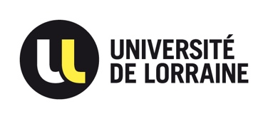
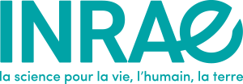
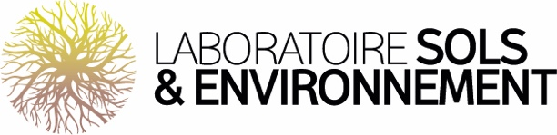

PhD Position
Investigation of Rhizodeposit Reactivity toward Iron and Trace Metal Elements

Work Environment, Missions, and Activities
You will be welcomed into the Sols et Environnement Laboratory (LSE), a Joint Research Unit between the University of Lorraine and INRAE (UMR 1120), to undertake a doctoral thesis entitled “Study of the reactivity of rhizodeposits with respect to iron and trace metal elements.” The PhD will be supervised by Thibault Sterckeman (Research Engineer, INRAE) and Pierre Leglize (Associate Professor, University of Lorraine).
Trace metal elements (TMEs) such as Cd, Cu, Ni, Pb, or Zn are among the main soil pollutants. Absorbed by the roots of cultivated plants, they can contaminate the food chain and pose risks to human health. The uptake flux of TMEs by roots depends on their speciation in the rhizospheric solution. It is generally accepted that only free ionic forms (M²⁺) can cross the cytoplasmic membrane of root cells via more or less specific transport systems. Complexes formed by metal ions with various inorganic and especially organic ligands (ML) are not directly internalized. However, they are not all inert and may dissociate near the root surface, releasing absorbable free ions. Ligands may originate from soil organic matter, microbial secretions, or root exudation. Root exudates are relatively abundant in the rhizosphere but remain poorly understood. Ligands exuded for iron acquisition could also interact with TMEs.
To model and predict the amount of TMEs taken up by a plant, one must know the amounts of free and complexed ions, as well as the ability of complexes to release free ions near the roots. It is therefore necessary to know the nature of the ligand, its exudation flux from the root, its stability constant with the metal in question, and its association/dissociation rates.
The objectives of this research are to identify the root exudates of dicotyledonous plants and their exudation factors, and to characterize the reactivity of these exudates with TMEs and iron.
The research will begin with a chemical characterization of root exudates and their production factors through metabolomic analysis under various experimental conditions. Different genotypes of Arabidopsis thaliana and the metal hyperaccumulator Noccaea caerulescens will be compared in both hydroponic and soil systems. The next step will involve identifying ligands for TMEs and iron using metabolomic analysis in the presence of model TMEs and immobilized metal affinity chromatography (IMAC). Finally, dynamic speciation measurements of TMEs in root exudate solutions will be carried out using electrochemical techniques (SCP, AGNES).
This research will rely on the cultivation facilities of the PEPLor platform, the analytical resources (HPLC-MS) of the PASM at ENSAIA, and collaborations with researchers from the Jean-Pierre Bourgin Institute (metabolomic analysis), the LRGP (IMAC), and the LIEC (electrochemical analysis).

PROFILE WE ARE LOOKING FOR
- Recommended education: Master’s degree or engineering diploma, with a specialization in chemistry, analytical chemistry, or natural substances chemistry.
- Desired knowledge: Chromatographic analysis.
- Valued experience: Prior experience in LC-MS, especially in untargeted metabolomic approaches, would be an asset.
- Required skills: Interest in experimental approaches and data analysis. Enjoyment of teamwork and interdisciplinary environments.

 Hosting Conditions  Unit: Sols et Environnement Laboratory  Postal code + city: 54500 Vandœuvre-lès-Nancy  Type of contract: Doctoral contract from the University of Lorraine  Contract duration: 3 years  Start date: 01/11/2025  Salary: €2,300 gross per month |  |  Application procedure  Go to:  https://adum.fr/as/ed/voirproposition.pl?site=adumR&matricule_prop=65844  Contact:  thibault.sterckeman@univ-lorraine.fr  pierre.leglize@univ-lorraine.fr

